** Morphometric Analysis of Ravi River Basin in Himachal Pradesh**

*Author details:*

1. *Nikesh Sharma, Assistant Professor of Geography, Government College Bharmour, District Chamba, Himachal Pradesh,* [*nikesh73925@gmail.com*](mailto:nikesh73925@gmail.com)*, 09418973925, 08894574772*

|  |  |
| --- | --- |
| *\* This is only required for authors selecting premium or super premium publication packages.* | |
| *Author 1 Photo* | *Author Biography in 100 words*  *Researcher is working as Assistant Professor of Geography in the Department of Higher Education, Govt. of Himachal Pradesh and presently posted at Govt. College Bharmour, District Chamba and the paper is based on his primary data based research conducted during 2010-2016 for PhD work.*  *Facebook Link: Nikesh Sharma*  *Twitter Link:*  *LinkedIn Link:* |

Morphometric analysis of Ravi River basin in Himachal Pradesh in highland region of Ravi basin is carried out. The basin is located at Chamba and Kangra Districts of Himachal Pradesh. Analyses of various Morphometric attributes are done to understand the geomorphologic evolutionary stages of basin. From the analysis it was inferred that this basin in matured stage. Geographically Ravi River (H.P.) Basin area is located between 32° 11' 30ʺ to 33° 01' 5ʺ North latitudes and 75°48' to 77°45' East Longitudes. The tract is mountainous, covered by the Dhauladhar and Pirpanjal ranges. The elevation varies from 559 meters to 5563 meters. On the other side the climate of the Ravi River Catchment area may be described as moderate summer and very cold winter. The precipitation is received in both during rainy season and winter season, but in high altitude an area in winter season receives precipitation is in the form of snow and in lower altitude area in the form of Rainfall from Monsoon winds as well as from Western Disturbance. The highest monthly temperature is experienced in June and lowest below 0˚ C in January. The Ravi River has a total of 5451 sq. Kms. Catchment area and its total length is about 158 Kms. in H.P. The Ravi River originates in Bara Bhangal area of the Multhan Tehsil of Kangra. This River rises at the elevation of 4300 mts on the southern side of the mid Himalayas. It flows through Bara Bhangal, Bara Bansu and Chamba District. It flows in forms of Rapids in its initial reaches with boulders seen scattered in the bed of the River. The Ravi River in this reach flows in a gorge with a River bed slope of 1:185 feet per mile, and is mostly fed by snow. It is called Ravi after meeting two tributaries Tantgari and Badal in Bara Bhangal area of Kangra District. The main tributaries of Ravi River are Badal,Tantgari, Budhil, Tundah Nala, Chirchind Nala, Nai, Batog Nala, Saho Nala, Baira and Siul etc. It left Himachal at Khairi and enters in Punjab.

**Keywords**

Basin, stream order, stream number, stream length, Bifurcation Ratio, stream length ratio, drainage density, stream frequency.

1. **Introduction**

The most important factors governing the development of landforms are resistance to erosion and geologic structure of the underlying rocks, Climate and vegetation covers. Morphometry is gaining importance in evaluating hydrologic parameters of drainage basins.

This basin (e.g. for stream characteristics, drainage basin or slopes) is becoming prevalent in geomorphology. Relationships between precisely measured aspects of landscape are revealed, particularly by the use of statistical methods. The study helped in finding out various morphometric parameters such as those dealing with length, area, slope and form factors of the Ravi River basin in Himachal Pradesh located in Chamba and Kangra Districts of Himachal Pradesh.

1. **Research Objective**

Morphometric aspects of Ravi River Basin area in Himachal Pradesh have been analyzed.

1. **Literature Review**

In 2013 Amminedu pointed out that environment impact study reveals that the area with sparse vegetation and shifting cultivation coupled with heavy rainfall in the steep slopes has been subjected to the removal of the fine fertile top soil through runoff, resulting in sedimentation and silting up of the River course in the lower reach of the Vamsadhara River basin. In 2013 Eadara, A. and Karanam, H. pointed out that the slope of the drainage basin has an important relation to infiltration, surface runoff,

soil moisture and ground water contribution to stream. In 2013 Iqbal, M. pointed out that the quantitative analysis of drainage system is an important aspect of characterization of watershed. He also pointed out that linear as well as shape factors are the most useful criterion for the morphometric classification of drainage basins which certainly control the runoff pattern, sediment yield and other hydrological parameters of the drainage basin. He also observed that linear parameters have direct relationship with erodability. In 2013 Prolay Mondal observed that the streams gradients become steeper (aggradation) or less steep (degradation) due to excess deposition or erosion of sediment, respectively. He also pointed out that aggradation and degradation are often the symptoms of a problem within this Birbhum district, such as changes in land use within the district that occur over a broad area and affectthe stream’s hydrology.

In 2014 Agrawal and Verma pointed out that runoff, soil and nutrient losses were more in agricultural lands as compared to other land uses. They also pointed out that orchard and agri-silvi-horti lands protected the soil against impact of falling rain drops, encouraged infiltration, reduced the surface runoff and consequently retained rainwater on soil surface for longer time. In 2014 Dogra and Talwar pointed out that ground water plays a vital role to meet the requirement of domestic irrigation and industrial sector, but due to over exploitation of groundwater the level is lower down. They also pointed out that groundwater level can be raised by rainwater harvesting and artificial recharge. In 2014 Gill pointed out that today it is a need to strengthen the input and recharge component to pace with changing climatic parameters. He also pointed out that the climatic conditions of western Himalayan region are controlled by western disturbances, monsoon, elnino, temperate location of Himalayas, location and extension of Himalayas. In 2014 Guleria S. S., Kishore Naval and S. Madhuri observed that the stream frequency decreases as the stream order increases and the densities of Ist order streams are higher in the northern, southern and south-eastern part of the Neugal Watershed area. They also pointed out that in this Watershed; the slope is controlled by the structure and the erosion processes which have resulted in varied landform leading to environmental hazards. In 2014 Kapoor and Shaban pointed out that in Kullu (H.P.) temperature are rising, where farmers are dependent on the rains for agriculture. In 2014 Sharma pointed out that water scarcity problem is mitigated by rainwater harvesting. He also studied factors influencing shortage of water, in situ water conservation, ex situ water conservation techniques. In 2014

Srivastava O. S., Denis D.M., and Srivastava S.K. concluded that the higher values of Rb in semi urban Watershed, Trans Yamuna Watershed shows strong structural control, while the lower values indicate that Watershed are not affected by structural disturbances. They also pointed out that the morphometric study is very useful for identifying and planning the ground water potential zones and Watershed management. In 2014 Sharma pointed out that land and water are the two most valuable and vital resources essentially required not only for sustenance of life but also for the economic and social progress of a region. He also pointed out that there are many factors responsible for soil erosion; include rainfall, soil type vegetation, topographic and morphological characteristics of the basin.

In 2015 Shaikh pointed out how Morphometry is useful to obtain quantitative information of a watershed. He also pointed out the drainage network of the basin exhibits as mainly dendritic type which indicates the homogeneity in texture and lack of structural control. In the same year Kumar pointed out drainage density and frequency are more and drainage texture is fine which shows that basin is impermeable and having low ground water recharging characters with sparse vegetation. They also pointed out the runoff of Paisuni basin is moderate to high. In 2015 Saha pointed out that GIS techniques are more reliable and accurate than conventional methods of morphometric analysis. In 2015 Dhawaskar pointed out that 1st and 2nd order streams are not useful for construction of check dams because these streams are situated on hilly terrains. She also pointed out that the Mhadei River basin exhibits dendritic drainage pattern. She also identify that the development of stream segments in the basin area is more or less affected by rainfall. In 2015 Rekha pointed out how morphometric analysis is important in any hydrological investigation and it is inevitable in development and management of drainage basin. She is also pointed out how relief aspect of the watershed plays an important role in drainage development surface and sub-surface water flow, permeability, landform development and associated features of the terrain. In 2015 Osano pointed out the analysis of watershed and morphometric parameters demonstrates that GIS and Remote sensing based approach is more appropriate and efficient than the conventional methods in understanding morphometric parameters and their influence on soils, landforms and eroded land characteristics in a River catchment. Through the approach, it is possible to explore the relationship between the drainage morphometry and properties of landforms and the analysis of different morphometric parameters. Drainage density and stream frequency from the result are more useful criteria for the morphometric classification of drainage system and pattern in Njoro River catchment. In 2015

Sangle pointed out how use of GIS and remote sensing to prepare management and planning of natural resources of the geography is widely acknowledged. Progress in these technologies offers many advantages of taking a synoptic view of the natural resources, natural features at a glance to quicker planning and management of the end user related issues. He also pointed out how work focuses on management of Natural resources used in water conservation, such as primarily drainage development, watershed evaluation and its characterization, harnessing the morphometric parameters of the topography. It's helpful in management of drought affected area and agriculture practices; finally enhances water tables and the requirement of water for food production ultimately full filled.

1. **Data Analysis/ Findings**

**Fluvial Morphometry**

Fluvial Morphometry is the measurement and mathematical analysis of configuration of earth surface and of the dimension of its landforms originate due to fluvial processes. The morphometric analysis is carried out through measurement of linear, aerial and relief aspects of the basin and slope contribution to understand the run-off characteristics of the area and potentiality of watershed corrosion. The measurement of various morphometric parameters namely stream order, stream length (Lu), mean stream length, bifurcation ratio, mean bifurcation ratio, drainage density, stream frequency and elongation ratio has been carried out. In the present study the drainage network has been obtained from survey of India toposheets of Chamba and Kangra Districts and the updated drainage network has been used for morphometric analysis. Morphometric studies in the field of hydrology were initiated in the 1940s and 1950s. Morphometry is the measurement and mathematical analysis of configuration of the Earth surface and the shape dimensions of its landforms. Structural and geomorphological features control the directions of flow of the tributaries. Drainage morphometric analysis gives overall view of the terrain information like hydrological, lithological, slope, relief, variations in the watershed, ground water recharge, porosity, soil characteristics, flood peak, rock resistant, permeability and runoff intensity and is useful for geological, hydrological, ground water prospects, civil engineering and environmental studies.

A Geographic information system (GIS) integrates hardware, software and data for capturing, managing, analyzing and displaying all forms of geographically referenced information. GIS allows viewing, understanding question, interpreting, and visualizing data in many ways that reveal relationships, patterns, and trends in the form of maps, globes, reports, and charts. GIS helps to answer question and solve problems by looking data in a way that is quickly understood and easily shared. GIS technology can be integrated into any enterprise information system framework. More than ever in histories one must manage preserve and restore natural resources and decision makers who must take action need a complete picture of the issues. Arc GIS platform helps to gain a deeper understanding of the problems and bring more accurate information and less guesswork to the table. Arc GIS (10.0) software is powerful tool found a significant role in scientific applications.

**4.2 Stream Ordering**

Stream ordering is a method of assigning a numeric order to links in a stream network. This order is a method for identifying and classifying types of streams based upon their number of tributaries. Some characteristics of streams can be inferred by simply knowing their order. The designated stream order is the first step in the drainage basin analysis. In the present study, ranking of streams has been carried out based on the method proposed by Strahler (1964). It is noticed from the table that the maximum frequency is in the case of first order streams. It is also observed that there is a decrease in stream frequency as the stream order increases. Stream ordering refers to the determination of the hierarchical position of a stream with in a drainage basin. A River basin consists of its several branches (segments) having different positions in the basin area and they have their own morphometric characteristics and therefore, it becomes necessary to locate the relative position of a segment in the basin, so that the hierarchical organization of stream segments is visualized. Thus stream order is defined as a measure of the position of a stream in the hierarchy of tributaries (Leopold et.al, 1969). A.N. Strahler modified the Horton’s scheme of stream ordering by removing the problem of reclassification and renumbering of streams. According to him each fingertip channel is designated as a segment of first order. At the junction of any two 1st order segments, a channel of 2nd order is produced and extends down to the point, where it joins another 2nd order segment where upon a segment of 3rd order results and so forth (A.N. Strahler, 1975). It may be mentioned that the hierarchical order increases only when two stream segments of equal order meet and form a junction. The order does not increase if a lower order stream segment meets a stream segment of higher order. Strahler’s scheme is popularly known as “stream segment method”.

In the Ravi River Basin in Himachal Pradesh drainage area there are 27701 streams of first order , 5162 of second order streams, 1094 of third order, 253 of fourth order, 62 of fifth order, 17 of sixth order, 3 of seventh order and 1 of eighth order stream (Table 1.1).

**Stream Length**

Stream length is measured from mouth of a River to drainage divide. Stream length is one of the most significant hydrological features of the basin as it reveals surface runoff characteristics. Streams with relatively short lengths are representative of areas with steep slopes and finer textures whereas longer lengths of stream are generally indicative of low gradients. The length of River network has been measured using GIS techniques. Length of the stream is indicative of the contributing area of the basin of that order. Generally, cumulative length of stream of a particular order is measured and the mean length (Lu) of that order (u) is obtained by dividing cumulative stream length by the number of segments of that order (Nu). The mean stream length (Lu) of a stream-channel segment of order (u) is a dimensionless property, which reveals the characteristic size of components of a drainage network and its contributing basin surfaces. The stream lengths calculated for Ravi River basin are given in (Table 1.2).

In Ravi River basin in Himachal Pradesh the total lengths of all orders stream are 20306.93 Kms. and the total streams numbers are 34293. The 1st order streams lengths are 14203.66 Kms. because the streams numbers are about 27701. The 2nd, 3rd, 4th, 5th, 6th, 7th and 8th order streams lengths are 3248.36, 1409.17, 712.42, 346.81, 187.53, 140.33 and 58.64 Kms. respectively in Ravi River basin in Himachal Pradesh (Table 4.2).

**Mean Stream Length**

Mean Stream Length of a stream channel system is a dimension less property revealing the characteristics of size of a component of drainage network and its contributing basin set.

Lu= _Lu/Nu

Where, _Lu= Total length of a order

Nu= No of stream of that order.

Mean stream length (Lsm) is a characteristic property related to the drainage network components and its associated basin surfaces (Strahler, 1964). This has been calculated by dividing the total stream length of order (u) by the number of streams of segments in the order. It is found out from Topographic Maps of Chamba and Kangra Districts that the mean stream lengths of first order streams are 0.51 Kms. in this basin. The 2nd, 3rd, 4th, 5th, 6th, 7th and 8th orders mean streams length are 0.63, 1.29, 2.82, 5.59, 11.03, 46.78, and 58.64 Kms. respectively in Ravi basin in Himachal Pradesh. It is also observed that with the increasing of streams order, the mean lengths are also increased (Table 1.3).

**Stream Length Ratio**

Stream length ratio (RL) is the ratio of the mean length of the one order to the next lower order of the stream segments. The cumulative mean lengths of stream segments of each of the successive orders in a catchment tend closely to approximate a direct geometric series in which the first term is the mean length of streams of the first order (Nishant, V. et al 2013; Horton 1945). Stream length Ratio (Rl) helps in identifying the geographical location of Hydro Electric Power stations (HEPs) and it is calculated by the following formulae;

(Rl) = Lu/Lu-1

(Rl) = Nu-1 / Nu

Where (Rl) = stream length ratio, Nu = length of an order, and Nu-1 = length

in the next higher order.

The Stream length ratio (RL) is the ratio of the mean length of the one order to the next lower order of the stream segments. In this basin the stream length ratio between 1st and 2nd order is 1.23 Kms., between 2nd and 3rd order is 2.05, between 3rd and 4th order is 2.19, between 4th and 5th order is 1.99, between 5th and 6th order is 1.97, between 6th and 7th order is 4.24 and between 7th and 8th order is 1.25 Kms. stream length ratio in Ravi River basin in Himachal Pradesh (Table 1.4).

**Bifurcation Ratio**

Bifurcation ratio is the ratio between the number of streams of any order and the number of streams of the next higher order. For example in a particular area there are three streams of the first order and have only one stream of second order, then the bifurcation ratio is 3% since there are three times as many streams of one order as of the next higher order. The bifurcation of stream segment is largely dependent on the composition and shape of a basin. It is mainly the structure, shape, size and climatic conditions of the Watershed which determine the bifurcation ratio of stream segments especially of the first order from the main channel. According to Schumn (1956), the term bifurcation ratio may be defined as the ratio of the number of the stream segments of given order to the number of segments of the next higher orders. Bifurcation ratio shows a small range of variation for different regions or for different environments except where the powerful geological control dominates (Strahlar, 1957). Bifurcation ratio is defined as the ratio of the number of stream of a given order to the number of stream to the next higher order which is expressed in terms of following equation-

Rb = Nu/ Nu+1

Where, Rb = Bifurcation Ratio.

Nu= Number of segments of a given order segment.

Nu+1=Number of segments of the next higher order.

It varies from 2 to 5. Rb is used to find out the degree of integration in drainage basin. Rb depends on the slope, physiography, and climate. Aerial aspects include different morphometric parameters, like drainage density, texture ratio, stream frequency, form factor, circularity ratio, elongation ratio and length of the overland flow. Bifurcation is the addition of lower order streams, which produce a next higher order stream. There is a constant geometric relationship between streams of lower order and higher order. (Strahlar, 1975) has described the bifurcation ratio in the following equation

RB = N4/B4+1

Where RB = Bifurcation ratio

N4 = Number of streams of a given order

N4+1=Number of streams of the next higher order

In 1964 Strahlar himself observed and declared that bifurcation ratio is a dimensionless property. Harton (1945) stated that bifurcation ratio is one of the most significant features of drainage basin. He concluded that there can be alteration in catchments geometry and bifurcation ratio can vary from lower order to higher order. But it will remain throughout the series.

The Mean Bifurcation ratio of Ravi River basin in Himachal Pradesh is 4.40. The bifurcation ratio between 1st and 2nd order stream is 5.37, between 2nd and 3rd order stream is 4.72, between 3rd and 4th order stream is 4.32, between 4th and 5th order stream is 4.08, between 5th and 6th order stream is 3.65, between 6th and 7th order stream is 5.67 and between 7th and 8th stream order is 3 (Table 1.5).

**Drainage Density**

Drainage density is defined as the total length of streams of all orders per drainage area. Density factor is related to climate, type of rocks, relief, infiltration capacity, vegetation cover, surface roughness has no significant correlation with drainage density. The drainage density indicates the closeness of spacing of channels (Horton, 1932). It may be considered as one of the methods of measurement of basin area. According to Horton, Drainage Density is defined ratio of total length of all stream segments in a given drainage basin to the total area of that basin. It is expressed by a formula:

DD = _L/A

Where, _L = Total length

A = Total area

The amount and type of precipitations influences directly to the quantity and characters of surface run-off. An area with high precipitation such as thunder showers loses greater percentage of rainfall in run-off resulting in more surface drainage lines. Amount of vegetation and rainfall absorption capacity of soils, which influences the rate of surface runoff, affects the drainage texture of an area. The similar condition of lithology and geologic structures, semi-arid regions have finer drainage density texture than humid regions. Low drainage density generally results in the areas of highly resistant or permeable sub-soil material, sparse vegetation and mountainous relief. Low drainage density leads to course Drainage texture while drainage density leads to fine drainage texture. Chorley (1957) and Morgan (1962) compared three lithologically similar areas in Britain and stated that a close relationship exists between drainage density and rainfall. In 1966 Carlton also emphasized the role of climate in influencing the drainage density. Horton’s method (as given above) yields only a single value (of drainage density) for the entire basin and hence it cannot be applied for the study of spatial variations of drainage density within a given basin. The simplest way to calculate drainage density on a regional scale is to divide the basin in to grid squares for one square mile or one square kilometer each and to measure the total stream lengths in each grid square and to group the derived data in to drainage density categories viz. (i) very low (Dd VL), (ii) Low (DdL), (iii) moderate (Ddm), (iv) high (Ddh) and (v) very high (Dd vh). The drainage density of

Ravi River Basin may be sub-divided into ten categories which are as following: (i) Below 1 (ii) 1.01 to 2 sq. Kms, (iii) 2.01 to 3.0, (iv) 3.01 to 4.0, and (v) 4.01 to5.0 (vi) 5.01 to 6.0 (vii) 6.01 to 7.0 (viii) 7.01 to 8.0 (ix) 8.01 to 9.0 and (x) above 9 Kms. per sq. Kms.

In Ravi River basin in Himachal Pradesh, the drainage density is categorized in to 10 categories. In Ravi River basin the drainage density is very high in lower stream orders areas because of dissected topography and due to this the erosion processes are also very high. It is observed that the canopy areas of Dhauladhar and Pirpanjal, the drainage density is very high of more than 9 Kms. per square kilometer.

It is also observed that in Ravi and its major tributaries bed areas, the drainage density is low. It is found out from drainage density map that in Glacier covered areas; the drainage density is also low. It is also found out that with the increasing of stream order the drainage density is decreasing (Figure 1.6).

**Stream Frequency/Channel Frequency**

The total number of stream segments of all orders per unit area is known as stream frequency (Horton, 1932). Hopefully, it is possible to have basins of same drainage density differing stream frequency and basins of the same stream frequency differing in drainage density. Stream Frequency is defined as the ratio between the number of stream segment per unit area which expressed by a formula

DF= _N/A where, _N= Total no of stream segment; A= Unit area in km2 or m2.

It is a technique which is also used in planning and development to identify land quality for optimum utilization. In Ravi River basin the stream frequency is 6.291139241. The stream frequency of Ravi River Basin may be sub-divided into 5 categories which are as following: (i) Below 5 streams per Kms. (ii) 6 to 10 streams per sq. Kms., (iii) 11 to 15 streams per sq. Kms., (iv) 16 to 20 streams per sq. Kms. and (v) above 20 streams per sq. Kms. It is found out that stream frequency below 5 streams per sq. Kms. is concentrated in glacier covered regions of Multhan area of Kangra district, Bharmour, Holi and Chaurah area of Chamba District of this basin in Himachal Pradesh (Figure 1.7).

1. **Conclusion**

Areal, Linear and Relief properties morphometric parameter, using GIS software is found to be immense utility in drainage basin, elevation, watershed prioritization for soil and water conservation, flood Prediction and natural resources management. Application of Morphometric approach revealed that there are total 34293 streams grooved with each other from order 1st to 8th sprawled over 5451 km2 area of the basin in Himachal Pradesh. Detailed study of Ravi River basin gives a useful direction for surface runoff and helps for natural resource development. Bifurcation ratio indicates that the drainage has covered by impermeable sub surface and high mountainous relief. Circulatory ratio, elongation ratio shows watershed have high slope and high peak flow. The study area shows that terrain is made up of mainly basaltic rock and exhibits dendritic and Herringbone drainage pattern is classified as highly sloping and high runoff zone which give rise to high drainage discharge. Thus study shows that the morphometric analysis using GIS helps to understand complete terrain parameters which lead to finalize watershed development planning and management with respect to water conservation.

1. **References**
2. Amminedu, E. et. al. (2013), An integrated approach for environmental impact studies on soil erosion in Vamsadhara River basin, India, International Journal of Advanced Research, Vol. 1, Issue 5, pp.366-371.
3. Prolay, M. (2013), Morphometric analysis of Birbhum District, Asian Journal of multidisciplinary studies, Vol.1, Issue 4, pp. 141-148.
4. Iqbal, M. et. al. (2013), Morphometric analysis of Shaliganga sub catchment, Kashmir valley, India using Geographical information system, International Journal of Engineering trends and Technology, Vol. 4, Issue1, pp.10-21.
5. Eadara, A. and Karanam, H. (2013), Slope studies of Vamsadhara River basin: A Quantitative approach, International Journal of Engineering and innovative Technology, Vol. 3, Issue 1, pp. 184-189.
6. Singh, R.B. and Kumar, P. (2014), Geographic and Socio-Economic Realities of Himachal Pradesh, Northwestern Himalaya, Springer, Vol. viii, p. 15.
7. Sharma, S.K.et.al. (2014), Assessing vulnerability to soil erosion of a watershed of Tons River basin in Madhya Pradesh using remote sensing and GIS, International Journal of Environmental Research and development, Vol. 4, No. 2, pp. 153-164.
8. Agrawal, G. and Verma, M.L. (2014), Runoff sediment and nutrient losses from different land uses in micro- watershed of Giri River in Solan district of Himachal Pradesh, Central ground water board, Dharamshala, pp. 11-16.
9. Srivastava, O.S. et. al. (2014), Quantitative morphometric analysis of a semi urban Watershed, trans Yamuna, drainage at Allahabad using Cartosat (DEM) data and GIS, Journal of modern engineering research, Vol.4, Issue 10, pp.1-8.
10. Guleria, S.S.et.al. (2014), Morphometry and geomorphological investigations of the Neugal Watershed, Beas River basin, using GIS tools, Journal of Environment and Earth Science, Vol. 4, No.2, pp.78-86.
11. Sharma, J.C. (2014), Rain water harvesting- a necessity; Central ground water board, Dharamshala, pp. 1-5.
12. Gill, R.S. (2014), Climate change and their effects on water resources of Himalayas, Central ground water board, Dharamshala, pp.64-65.
13. Dogra, M. and Talwar, N. (2014), Various governmental schemes of watershed management of Himalayas especially ground water recharge and rainwater harvesting, Central ground water board, Dharamshala, pp. 49-54.
14. Kapoor, M. and Shaban, A. (2014), Climate change in Himachal evidence from Kullu region, Economic and Political Weekly, Vol. XLIX, No.4, pp.19-21.
15. Shaikh, M. and Birajdar, F. (2015), Analysis of watershed characteristics using Remote sensing and GIS techniques, International Journal of innovative Research in Science, Vol. 4, issue 4, pp. 1971-1976.
16. Kumar, A. et. al. (2015), Morphometric analysis and hydrogeomorphological implication of Paisuni River basin Chitrakoot, Madhya Pradesh, India, Vol. 5(1), pp. 68-73.
17. Saha, S. and Mukhopadhyay, S. (2015), Determination of significant geomorphic parameters of Kunur River basin through Principal component analysis, Vol. 4, No. 8, pp. 232-242.
18. Dhawaskar, P.K. (2015), Morphometric analysis of Mhadei River basin using SRTM data and GIS, Vol.3, pp. 1-7.
19. Rekha, V.B.(2015), Micro-watershed prioritization of Kokkaya sub-watershed, Manimala River basin, Kerala, India, International Journal of innovation and scientific research, Vol.16, No.1, pp. 86-94.
20. Osano, P.O. (2015), Morphometric characterization and hydrological assessments of River Njoro watershed Using System for Automated Geoscientific Analysis (SAGA) and Shuttle Radar Topographic Mission (SRTM) digital elevation Model, International Journal of Advances in Remote Sensing and GIS, Vol. 4, No. 1, pp. 37-44.
21. Sangle, S.A. (2015), Morphometric Analysis of Watershed of Sub-drainage of Godavari River in Marathwada, Ambad Region by using Remote Sensing, International Journal of computer applications, Vol. 125, No.5, pp. 30-35.
22. Strahler, A.N. (1964), Quantitative Geomorphology of Drainage basins and Channel Networks; Handbook of applied hydrology, McGraw- Hill Book Cooperation, New York. pp. 4-76.
23. Nishant, V. et. al. (2013), Morphometric analysis using Geographic Information System (GIS) for sustainable development of hydropower projects in the lower Satluj River catchment in Himachal Pradesh, India, International journal of Geomatics and Geosciences, No. 3(3), pp. 464-473.
24. Schumm, S.A (1956), Evolution of Drainage Systems & Slopes in Badlands at Perth Anboy, New Jersey, Bulletin of the Geological Society of America, No.67, pp.597-646.
25. Schumm, S. (1977), The fluvial system, New York: J. Willey.
26. Rudraiah, G.(2008), Morphometry Using Remote Sensing and GIS Techniques in the Sub-Basins of Kagna River Basin, Gulburga District, Karnataka, India, Journal of Indian society of Remote Sensing No. 36, pp. 351-360.
27. Das, G. (2000), Hydrology and Soil Conservation Engineering, Prentice Hall of India, New Delhi.
28. IMSD Special Programme- Baghmundi Block, Puruliya District, West Bengal (1996), State Remote Sensing Centre, DST & NES, Govt. of West Bengal, unpublished report.
29. Integrated Mission for Sustainable Development, Technical Guidelines, National Remote Sensing Agency, Department of Space, Government of India, Balanagar, Hyderabad-500037, December-1995.
30. Kuldeep, P. and Upasana, P. (2011), Quantitative Morphometric Analysis of a Watershed of Yamuna Basin, India using ASTER (DEM) Data and GIS, International Journal of Geomatics and Geosciences, 2(1), pp. 248-269.
31. Seethapathi, P.V. et. al. (2008), Hydrology of Small Watersheds, New Delhi: TERI (The Energy and Resources Institute).
32. Sethupathi, A.S. et. al. (2011), Prioritization of mini watersheds based on Morphometric analysis using Remote Sensing and GIS techniques in a draught prone Bargur Mathur sub watersheds, Ponnaiyar River basin, India, International Journal of Geomatics and Geosciences, 2(2), pp. 403-414.
33. Sandipan, G. (2011),Quantitative and Spatial Analysis of Fluvial Erosion in relation to Morphometric Attributes of Sarujharna Basin, East Singhbhum, Jharkhand, International Journal of Geomatics and Geosciences, 2(1), pp. 71-90.
34. Thakkar, A.K. and Dhiman, S.D. (2007), Morphometric Analysis and Prioritization of mini watersheds in Mohr Watershed, Gujarat Using Remote Sensing and GIS technique, Journal of the Indian society of Remote Sensing, 35(4), pp.313-321.
35. GSI (Geological Survey of India) (2002), Lecture Notes on First Course on Application of Remote Sensing and GIS for Mineral Exploration, Module-I, Photo Geology, p. 84.
36. **Tables and Figures**

**Table 1**

**Stream ordering of Ravi River Basin in Himachal Pradesh**

|  |  |  |
| --- | --- | --- |
| Sr. Number | Stream Order | Number of Streams |
| 1 | 1 | 27701 |
| 2 | 2 | 5162 |
| 3 | 3 | 1094 |
| 4 | 4 | 253 |
| 5 | 5 | 62 |
| 6 | 6 | 17 |
| 7 | 7 | 3 |
| 8 | 8 | 1 |
| Total |  | 34293 |

**Source:** Calculated from Topographical Map of Kangra and Chamba, Districts.



**Figure: 1**

**Table 2**

**Stream Lengths of Different order streams of Ravi River**

**Basin in Himachal Pradesh**

|  |  |  |  |
| --- | --- | --- | --- |
| **Sr. No.** | **Stream Order** | **No. of Streams** | **Total length in Kms.** |
| 1 | 1 | 27701 | 14203.66227 |
| 2 | 2 | 5162 | 3248.358359 |
| 3 | 3 | 1094 | 1409.174234 |
| 4 | 4 | 253 | 712.417057 |
| 5 | 5 | 62 | 346.811778 |
| 6 | 6 | 17 | 187.52995 |
| 7 | 7 | 3 | 140.327496 |
| 8 | 8 | 1 | 58.644726 |
|  |  | Total=34293 | 20306.92583 |

**Source:** Stream lengths are calculated from Topographical Sheets of Chamba and Kangra, District.

**Figure: 2**

**Table 3**

**Mean Stream Length of Ravi River Basin in Himachal Pradesh**

|  |  |  |  |  |
| --- | --- | --- | --- | --- |
| **Sr.**  **No** | **Stream Order** | **Number**  **of stream** | **Total**  **Length in Kms.** | **Mean**  **stream length** |
| 1 | 1st | 27701 | 14203.66227 | 0.51274908 |
| 2 | 2nd | 5162 | 3248.358359 | 0.629282906 |
| 3 | 3rd | 1094 | 1409.174234 | 1.28809345 |
| 4 | 4th | 253 | 712.417057 | 2.815877696 |
| 5 | 5th | 62 | 346.811778 | 5.593738355 |
| 6 | 6th | 17 | 187.52995 | 11.03117353 |
| 7 | 7th | 3 | 140.327496 | 46.775832 |
| 8 | 8th | 1 | 58.644726 | 58.644726 |

**Source:** Mean Stream Lengths are calculated from topographical Map of Kangra and Chamba, Districts.

**Figure: 3**

**Table 4**

**Stream Length Ratio of Ravi River Basin in Himachal Pradesh**

|  |  |  |  |  |  |
| --- | --- | --- | --- | --- | --- |
| **Sr. No** | **Stream Order** | **Number of stream** | **Total Length in Kms.** | **Mean stream Length** | **Stream length ratio** |
| 1 | 1st | 27701 | 14203.66227 | 0.51274908 | 1.227272617 |
| 2 | 2nd | 5162 | 3248.358359 | 0.629282906 | 2.046922677 |
| 3 | 3rd | 1094 | 1409.174234 | 1.28809345 | 2.186081838 |
| 4 | 4th | 253 | 712.417057 | 2.815877696 | 1.986499046 |
| 5 | 5th | 62 | 346.811778 | 5.593738355 | 1.972057474 |
| 6 | 6th | 17 | 187.52995 | 11.03117353 | 4.240331446 |
| 7 | 7th | 3 | 140.327496 | 46.775832 | 1.25373988 |
| 8 | 8th | 1 | 58.644726 | 58.644726 |  |

**Source:** Stream length ratio is calculated from Topographical Map of Kangra and Chamba Districts.

**Figure: 4**

**Table 5**

**Bifurcation Ratio of Ravi River Basin in Himachal Pradesh**

|  |  |  |  |  |
| --- | --- | --- | --- | --- |
| **Sr. No.** | **Stream Order** | **Number of streams** | **Bifurcation ratio** | **Mean Bifurcation Ratio** |
| 1 | 1st | 27701 | 5.36633088 | 4.40 |
| 2 | 2nd | 5162 | 4.718464351 |
| 3 | 3rd | 1094 | 4.324110672 |
| 4 | 4th | 253 | 4.080645161 |
| 5 | 5th | 62 | 3.647058824 |
| 6 | 6th | 17 | 5.666666667 |
| 7 | 7th | 3 | 3 |
| 8 | 8th | 1 |  |

**Source:** Bifurcation ratio is calculated from Topographical map of Kangra and Chamba Districts.

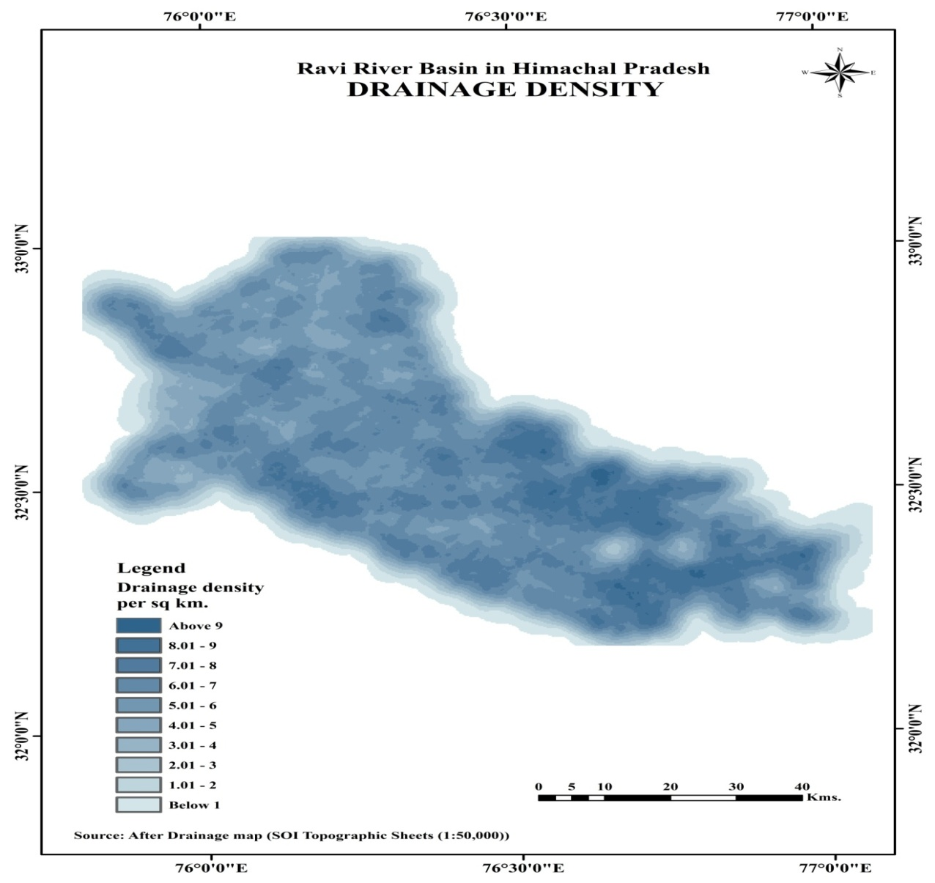

**Figure 5**

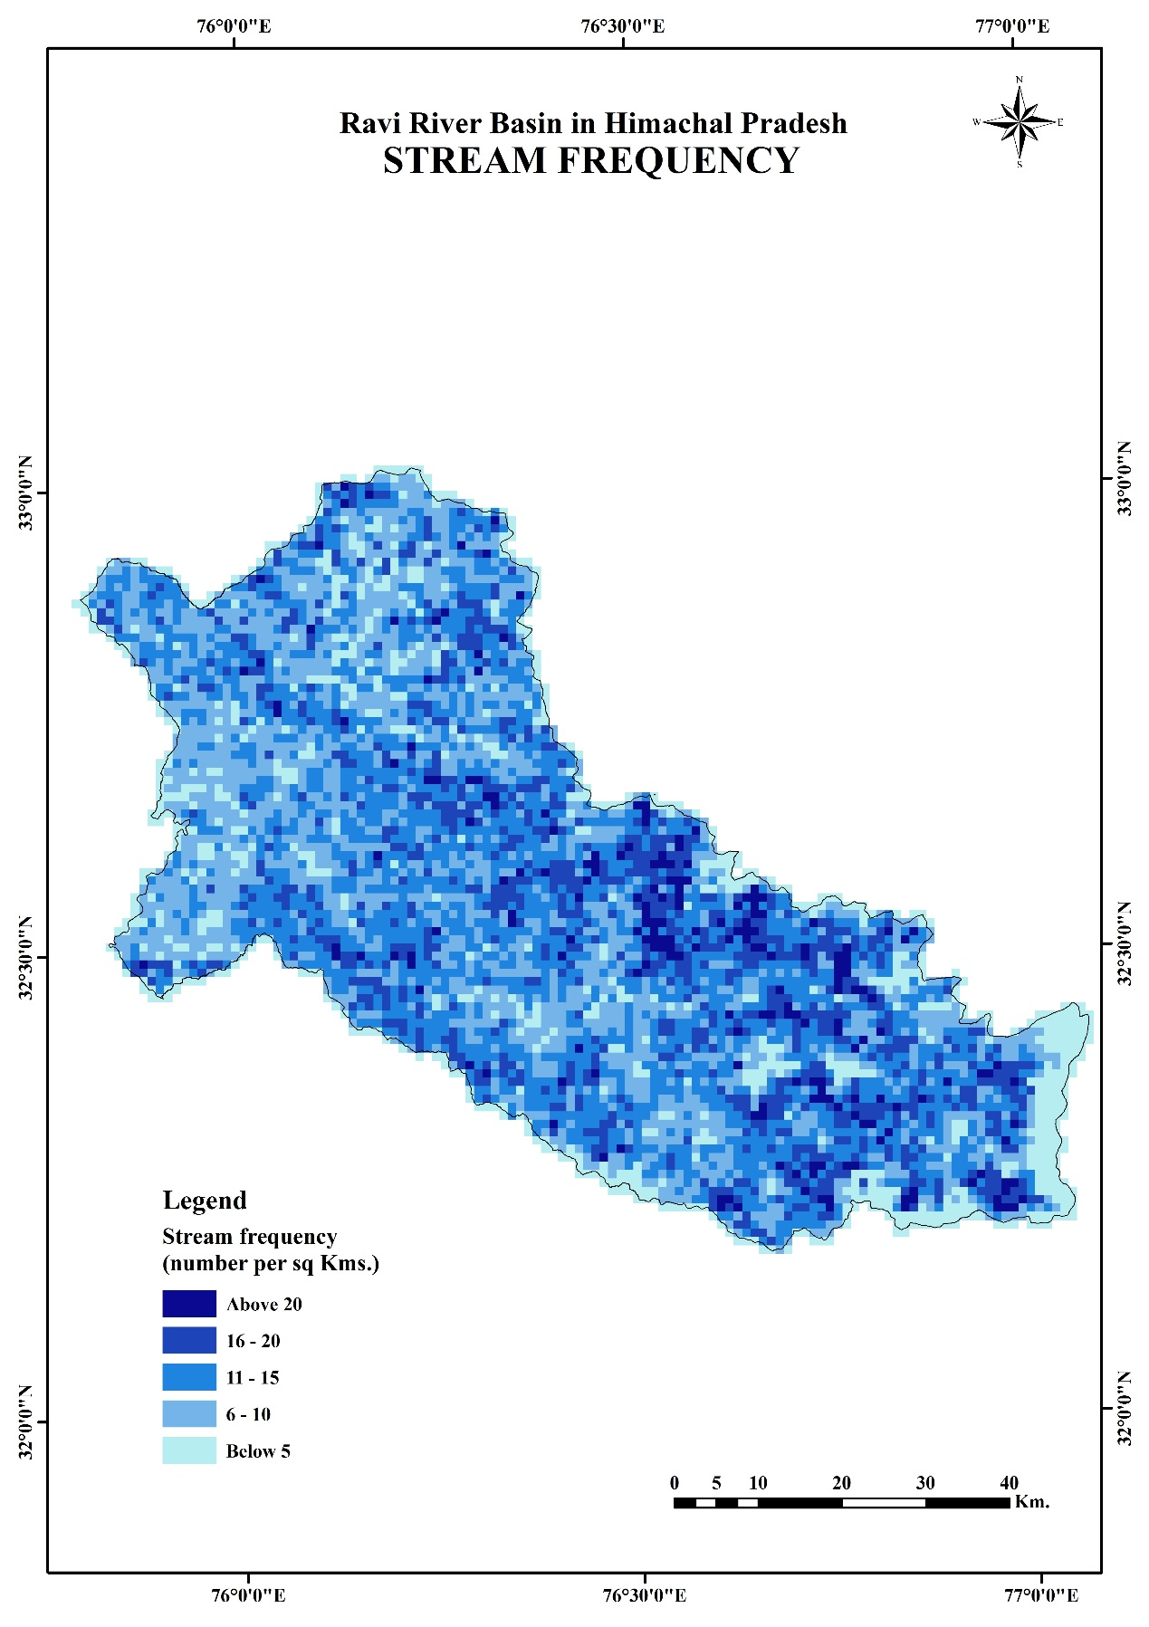

**Source: After Drainage Map (SOI topographic sheets of 1:50,000**

**Figure 6**